E-COMMERCE ORDER MANAGEMENT SYSTEM
A DBMS Capstone Project Report submitted in partial fulfillment of the requirements for the award of the degree of
BACHELOR OF TECHNOLOGY
in
ARTIFICIAL INTELLIGENCE AND MACHINE LEARNING

Submitted By
G.RISHI – 25B11AI318
T.ARAVINDH – 25B11AIB92
I.SRIKAR – 25B11AI408
M.SUDHARANI – 25B11AI698

Under the esteemed guidance of
Mr. T.Srinivasulu M.Tech, (Ph.D.)
Assistant Professor



DEPARTMENT OF ARTIFICIAL INTELLIGENCE AND MACHINE LEARNING
ADITYA UNIVERSITY
(Formerly Aditya Engineering College (A))
Aditya Nagar, ADB Road, Surampalem, Andhra Pradesh, India
2026 – 2027

Aditya Nagar, ADB Road, Surampalem, Andhra Pradesh, India
DEPARTMENT OF ARTIFICIAL INTELLIGENCE AND MACHINE LEARNING
CERTIFICATE
This is to certify that the DBMS Capstone Project report entitled “E-COMMERCE ORDER MANAGEMENT SYSTEM” is being submitted by G.RISHI (Roll No. 25B11AI318), T.ARAVINDH (Roll No. 25B11AIB92), I.SRIKAR (Roll No.25B11AI408) and M.SUDHA RANI (Roll No. 25B11AI698) in partial fulfillment of the requirements for the award of the B.Tech. degree in Artificial Intelligence and Machine Learning. The work documented in this report was carried out as part of the Capstone Project for the course Database Management Systems (2501IT05) during the academic year 2026–2027, and records the database design, implementation, and documentation undertaken by the team.

Project Guide Head of the Department
Mr. T. Srinivasulu, M. Tech, (Ph.D.) Dr. K. Naga Bhargavi, M. Tech, Ph.D. Associate professor Associate Professor & HOD

External Examiner

DECLARATION
We hereby declare that the DBMS Capstone Project entitled “E-COMMERCE ORDER MANAGEMENT SYSTEM” is a genuine work carried out by us. The database design, SQL implementation, queries and documentation presented in this report are our own work, completed under the guidance of Mr. T. Srinivasulu, Department of ARTIFICIAL INTELLIGENCE AND MACHINE LEARNING, Aditya University, Surampalem. We further declare that this work has not been submitted, in full or in part, for the award of any degree of this or any other educational institution.

Project Associates
G.RISHI – 25B11AI318
T.ARAVINDH – 25B11AIB92
I.SRIKAR – 25B11AI408
M.SUDHARANI – 25B11AI698

Date: ____________
Place: Surampalem

ACKNOWLEDGEMENT
It is with immense pleasure that we express our indebted gratitude to our project guide Mr. T. Srinivasulu , Department of ARTIFICIAL INTELLIGENCE AND MACHINE LEARNING
, who guided us throughout the capstone project. We are thankful for the constant encouragement and valuable suggestions received at every review stage.
We are grateful to Dr. K. Naga Bhargavi, Head of the Department, for inspiring us and for arranging the facilities and resources needed for this project.
We extend our sincere thanks to the Management, Dr. M. Sreenivasa Reddy, Deputy Pro-Chancellor, Dr. M. B. Srinivas, Vice-Chancellor, and Dr. A. Ramesh, Pro Vice-Chancellor (Engineering & Sciences), for providing an excellent academic environment.
Not to forget, we thank the Teaching and Non-Teaching Staff, our parents and our friends, who have directly or indirectly supported us in completing this project on time.

Project Associates
G.RISHI – 25B11AI318
T.ARAVINDH – 25B11AIB92
I.SRIKAR – 25B11AI408
M.SUDHARANI – 25B11AI698

ABSTRACT

The E-Commerce Order Management System operates within the retail domain to bridge the gap between digital storefronts and physical inventory fulfillment. This database solves the critical problem of fragmented inventory tracking, order processing bottlenecks, and uncoordinated customer data by centralizing transactional workflows. The purpose and scope of this database are to provide a robust, scalable backend capable of managing the complete lifecycle of online orders, from user registration and product catalog browsing to payment processing and final shipment tracking. The relational schema is structured around seven core entities, with major tables dedicated to Customers, Products, Categories, Orders, Order Items, Payments, and Shipments. Implemented using MySQL as the primary Relational Database Management System alongside MySQL Workbench for schema design and execution, the system relies on complex SQL operations. These include multi-table JOIN queries to fetch comprehensive order histories, aggregate functions to calculate total sales revenue and inventory valuation, and stored procedures paired with transactions to ensure data integrity during checkout. The successful outcome achieved is a fully normalized database that minimizes data redundancy, accelerates query performance, and guarantees reliable, error-free order processing for modern e-commerce operations.

INDEX
Chapter | Title | Page No.
 | Certificate | i
 | Declaration | ii
 | Acknowledgement | iii
 | Abstract | iv
 | List of Figures | v
 | List of Tables | vi
1 | Introduction
 | 1.1 Introduction to the Domain
 | 1.2 Problem Statement
 | 1.3 Motivation and Need for a Database
 | 1.4 Objectives of the Project
 | 1.5 Scope of the Project
 | 1.6 Organization of the Report
2 | System Study and Tools
 | 2.1 Existing System and Its Limitations
 | 2.2 Proposed Database System
 | 2.3 Tools and Technologies Used
 | 2.4 Software and Hardware Requirements
3 | Database Design (Review – I)
 | 3.1 Identified Entities
 | 3.2 Entity Attributes and Attribute Types
 | 3.3 ER Diagram
 | 3.4 Relationships and Cardinality
 | 3.5 Relational Database Schema
 | 3.6 Primary Keys and Foreign Keys
 | 3.7 Normalization up to 3NF
4 | Database Implementation (Review – II)
 | 4.1 Database and Table Creation – DDL
 | 4.2 Sample Data Insertion – DML
 | 4.3 Constraints and Data Integrity
 | 4.4 Data Validation Rules
5 | SQL Operations and Queries
 | 5.1 DQL – Basic Retrieval Queries
 | 5.2 Join Operations
 | 5.3 Aggregate Functions, GROUP BY and HAVING
 | 5.4 Nested and Correlated Subqueries
 | 5.5 Views and Relational Set Operations
 | 5.6 DCL and TCL Operations
6 | Modules and Functionalities
7 | Results – Sample Outputs and Screenshots
8 | Testing and Data Validation
9 | GitHub Repository and Team Contribution
10 | Conclusion and Future Enhancements
 | References
 | Appendix A – Complete SQL Script

LIST OF FIGURES

Figure No. | Title of the Figure
Fig. 3.1 | ER Diagram of the ecommerce order Management System
Fig. 3.2 | Relational Schema Diagram
Fig. 4.1 | Successful Creation of Tables
Fig. 4.2 | Sample Data Inserted into the Tables
Fig. 7.1 | JOINING MULTIPLE TABLES

LIST OF TABLES

Table No. | Title of the Table
Table 2.1 | Tools and Technologies Used
Table 2.2 | Software and Hardware Requirements
Table 3.1 | Entities Identified for the Selected Domain
Table 3.2 | Attributes of Each Entity
Table 3.3 | Relationships and Cardinality
Table 3.4 | Relational Database Schema
Table 3.5 | Primary Key and Foreign Key Definitions
Table 3.6 | Normalization Steps
Table 4.1 | Sample Data Summary
Table 4.2 | Constraints and Data Integrity Rules
Table 6.1 | Modules and Their Functionalities
Table 8.1 | Test Cases and Results
Table 9.1 | Team Responsibilities
Table 9.2 | Review-wise Progress Record

CHAPTER 1: INTRODUCTION

1.1 Introduction to the Domain
The selected domain for this project is E-Commerce, specifically focused on a modern digital retail platform that connects online consumers with a vast inventory of consumer goods. In this context, the organization operates as a digital-first marketplace, facilitating seamless browsing, purchasing, and fulfillment of products ranging from electronics to apparel. Unlike traditional brick-and-mortar storefronts, an e-commerce organization relies entirely on digital infrastructure to manage storefront displays, process electronic payments, coordinate third-party logistics, and handle customer service interactions around the clock.

Day-to-day operations involve handling a massive and continuous influx of dynamic information across multiple functional areas. The system must capture and update user account details, shipping addresses, and authentication credentials. Simultaneously, it tracks real-time inventory levels, product catalog specifications, pricing tiers, and category hierarchies. Every transaction generates critical operational data, including shopping cart contents, order statuses, billing information, payment gateway tokens, and shipment tracking updates. Managing this high-volume data accurately is vital to prevent overselling, ensure secure financial settlements, and provide customers with timely updates regarding their purchases.

1.2 Problem Statement
E-commerce systems manage large amounts of information related to customers, addresses, products, categories, orders, order items, and payments. When this information is not properly organized, it can lead to duplicate records, inconsistent data, difficulty in tracking orders, and errors in maintaining payment and product details.
The existing approach may make it difficult to efficiently retrieve and update related information. It can also become challenging to maintain accurate relationships between customers, orders, products, and payments as the amount of data increases.
The proposed E-Commerce Order Management Database addresses these problems by organizing the information into seven related tables. Primary Keys and Foreign Keys establish relationships between the tables, while database constraints help maintain data integrity. SQL operations and queries allow users to efficiently insert, update, delete, retrieve, and analyze information. This provides a more organized, consistent, and reliable approach to e-commerce order management.

1.3 Motivation and Need for a Database

A Database Management System (DBMS) is essential for an E-Commerce domain rather than relying on flat files or spreadsheets due to the high volume, complexity, and critical nature of online transactions. Here is why a DBMS is required:

- Concurrency Control and Multi-User Access: E-commerce platforms handle thousands of customers browsing catalogs, modifying shopping carts, and checking out simultaneously. A DBMS provides robust concurrency control using locking mechanisms and isolation levels, ensuring that two users purchasing the last item in stock simultaneously do not result in an inventory oversell. Spreadsheets would lock out users or overwrite concurrent updates, leading to catastrophic data corruption.

- ACID Transactions for Financial Safety: Order placement involves multiple coordinated steps—deducting stock, processing payment, creating the order record, and generating a shipment. A DBMS guarantees ACID properties (Atomicity, Consistency, Isolation, Durability), ensuring that either the entire checkout transaction completes successfully or rolls back completely if an error occurs. Flat files cannot automatically roll back partial writes.

- Scalability and Complex Querying: As product catalogs scale to millions of items and transaction histories grow, flat files and spreadsheets slow down drastically. A DBMS utilizes optimized query engines, indexing, and multi-table joins to retrieve customer profiles, calculate sales analytics, or filter products instantly, which would be entirely unmanageable across hundreds of disconnected files.

- Centralized Security and Access Control: E-commerce data contains sensitive Personally Identifiable Information (PII) and payment metadata. A DBMS provides fine-grained access control, role-based security, and encryption standards, whereas spreadsheets offer limited, easily bypassed security controls when shared across teams.

1.4 Objectives of the Project
Objective 1: To design a relational database containing 7 interconnected tables for managing e-commerce data.
Objective 2: To maintain accurate information about customers, addresses, categories, products, orders, order items, and payments.
Objective 3: To establish Primary Key and Foreign Key relationships to maintain data integrity and consistency.
Objective 4: To implement DDL, DML, DQL, CRUD operations, joins, and aggregate queries for efficient data management and retrieval.
Objective 5: To reduce data duplication and inconsistencies and provide an organized database for efficient e-commerce order management.

1.5 Scope of the Project
Scope of the E-Commerce Database
To ensure the system remains well-defined and manageable, the boundaries of the database are outlined below by detailing what it covers and what it intentionally excludes.

What the Database Covers
The database is strictly scoped to handle the core operational workflows of an online retail platform, focusing on:
- Customer Management: Storage of user profiles, authentication credentials, and billing/shipping addresses.
- Product Catalog & Inventory: Management of products, categories, pricing, stock levels, and supplier or brand associations.
- Order Processing: Tracking the entire lifecycle of a customer order, from shopping cart generation to order placement, status updates, and line-item details.
- Financial Transactions: Recording payment details, transaction statuses, payment methods, and payment gateway responses linked to specific orders.
- Fulfillment & Logistics: Monitoring shipment generation, tracking numbers, carrier details, and delivery statuses.

What the Database Does Not Cover
To prevent scope creep, the database intentionally excludes peripheral or advanced enterprise systems that are typically handled by third-party services or separate enterprise resource planning (ERP) modules:
- Third-Party Payment Gateway Integration Logic: It stores payment transaction tokens, statuses, and logs, but does not handle the underlying cryptographic processing or communication with external processors like Stripe or PayPal.

- Advanced Warehouse Robotics and Supply Chain Procurement: It tracks stock quantities and supplier names, but does not manage automated warehouse conveyor systems, purchase orders to raw material suppliers, or multi-warehouse freight routing.
- Human Resources and Employee Payroll: It does not manage internal staff accounts, employee scheduling, salaries, or internal administrative tracking.
- Customer Support Ticketing: While it stores customer profiles and orders, it does not include ticketing systems for customer service complaints, live chat histories, or return merchandise authorization (RMA) ticket workflows.
- Digital Marketing & Recommendation Engines: It does not store real-time user clickstream data, personalized web browsing histories, or marketing campaign analytics (e.g., email open rates, ad click-throughs).

1.6 Organization of the Report
This report is organized into ten chapters. Chapter 2 presents the system study and the tools used. Chapter 3 covers the complete database design including the ER diagram, relational schema and normalization. Chapter 4 describes the database implementation with DDL and sample data. Chapter 5 presents the SQL operations and queries executed. Chapter 6 explains the modules and functionalities. Chapter 7 presents the results with sample outputs. Chapter 8 covers testing and data validation. Chapter 9 details the GitHub repository and the contribution of each team member. Chapter 10 concludes the report and outlines future enhancements.

CHAPTER 2: SYSTEM STUDY AND TOOLS
2.1 Existing System and Its Limitations
Before implementing a centralized relational database management system, many growing e-commerce businesses rely on fragmented file systems, manual record-keeping, and decentralized spreadsheets to manage their operations. In this legacy approach, customer accounts, product catalogs, order records, and shipping manifests are typically stored in separate, isolated files or spreadsheets managed across different departments.

Limitations of the Existing Approach
- High Data Redundancy: Customer details, shipping addresses, and product descriptions are repeatedly duplicated across multiple files and department logs, unnecessarily wasting storage space and creating administrative bottlenecks.
- Data Inconsistency and Anomalies: When a customer updates their phone number or a product undergoes a price change, the update must be manually applied across every individual spreadsheet. Failure to update all locations results in conflicting records, such as an order referencing an outdated price or shipping address.

- Difficulty in Data Retrieval and Reporting: Generating business insights—such as evaluating monthly sales performance, tracking top-selling product categories, or checking individual customer order histories—requires manually cross-referencing, filtering, and merging disjointed files, which is time-consuming and highly prone to human error.
- Absence of Native Integrity Checks: Flat files and spreadsheets lack built-in relational constraints (such as foreign keys, data type enforcement, or CHECK constraints). This permits invalid entries—like negative product prices or improperly formatted email addresses—and allows orphaned records to exist, such as an order item linked to a product that has been deleted from the catalog.
- Lack of Concurrency Control: Spreadsheets cannot safely handle multiple users modifying the same document simultaneously. In an e-commerce context, this limitation causes data overwrites, race conditions, and catastrophic inventory tracking errors when multiple customers attempt to purchase items at the same time.

2.2 Proposed Database System
The proposed system is a single relational database in which each fact is stored once. Customer, Product, Category, and Order details are held in their own tables; the many-to-many association between orders and products is resolved by the Order Items table, and each order payment and shipment record maps directly to its respective transaction. Foreign keys make orphan records impossible, CHECK constraints keep product prices and stock quantities within valid ranges, and UNIQUE constraints prevent duplicate customer emails and SKU codes. Reports that were previously manual are obtained by a single SELECT statement, and frequently used reports are stored as views.

2.3 Tools and Technologies Used

Table 2.1: Tools and Technologies Used
Category | Tool / Technology Used | Version / Remarks
Database Server | MySQL Community Server | Version 8.0 / Relational Database Management System
Query & Admin Tool | MySQL Workbench | Version 8.0 / Schema design, SQL execution, and administration
ER Diagram Tool | draw.io (diagrams.net) | Web-based visual modeling for Entity-Relationship diagrams
Alternative Admin Tool | dbfiddle.dev | Online SQL testing and script sharing environment
Version Control | GitHub | Source code and script repository tracking
Documentation & Reports | Microsoft Word | Project report writing and formatting

2.4 Software and Hardware Requirements
Table 2.2: Software and Hardware Requirements

Requirement Type | Specification
Operating System | Windows 11 / macOS Ventura (or higher) / Linux Ubuntu 22.04 LTS
Processor (CPU) | Intel Core i5 / AMD Ryzen 5 (or equivalent multi-core processor)
Memory (RAM) | Minimum 8 GB RAM (16 GB recommended for optimal performance)
Storage | 5 GB of available disk space (SSD recommended)
Database Server | MySQL Community Server (Version 8.0)
Database Administration Tool | MySQL Workbench (Version 8.0)
Visual Modeling Tool | draw.io (diagrams.net) for ER diagram generation
Version Control & Documentation | Git / GitHub, Microsoft Word

CHAPTER 3: DATABASE DESIGN

3.1 Identified Entities

S.No | Entity Name | Description
1 | Customer | Stores personal details, authentication credentials, and contact information for registered users of the e-commerce platform.
2 | Category | Classifies products into hierarchical or grouped segments to facilitate structured catalog browsing and filtering.
3 | Product | Maintains information regarding item titles, descriptions, pricing, SKU codes, and available inventory stock levels.
4 | Order | Captures high-level transaction data placed by customers, including order dates, total costs, and current fulfillment statuses.
5 | Order_Item | Resolves the many-to-many relationship between orders and products by storing specific quantities and purchase prices per line item.
6 | Payment | Records financial transaction logs, payment methods, transaction tokens, and payment statuses linked to specific customer orders.
7 | Shipment | Tracks logistical delivery details including carrier names, tracking numbers, shipping addresses, and delivery milestones.

3.2 Entity Attributes and Attribute Types

Entity | Attribute | Data Type | Key (PK/FK/—) | Attribute Type
Customer | customer_id | INT | PK | Simple
 | first_name | VARCHAR(50) | — | Composite part
 | last_name | VARCHAR(50) | — | Composite part
 | email | VARCHAR(100) | — | Simple
 | registration_date | DATE | — | Simple
Address | address_id | INT | PK | Simple
 | customer_id | INT | FK | Simple
 | street | VARCHAR(200) | — | Composite part
 | city | VARCHAR(100) | — | Composite part
 | state | VARCHAR(100) | — | Composite part
 | pincode | VARCHAR(10) | — | Composite part
 | address_type | VARCHAR(20) | — | Simple
Category | category_id | INT | PK | Simple
 | category_name | VARCHAR(100) | — | Simple
 | parent_category_id | INT | FK | Simple
Product | product_id | INT | PK | Simple
 | product_name | VARCHAR(200) | — | Simple
 | description | TEXT | — | Simple
 | price | DECIMAL(10,2) | — | Simple
 | stock_quantity | INT | — | Simple
 | category_id | INT | FK | Simple
Order | order_id | INT | PK | Simple
 | customer_id | INT | FK | Simple
 | address_id | INT | FK | Simple
 | order_date | DATE | — | Simple
 | order_status | VARCHAR(30) | — | Simple
Order_Item | item_id | INT | PK | Simple
 | order_id | INT | FK | Simple
 | product_id | INT | FK | Simple
 | quantity | INT | — | Simple
 | unit_price | DECIMAL(10,2) | — | Simple
Payment | payment_id | INT | PK | Simple
 | order_id | INT | FK | Simple
 | payment_date | DATE | — | Simple
 | amount | DECIMAL(10,2) | — | Simple
 | method | VARCHAR(30) | — | Simple
 | status | VARCHAR(20) | — | Simple
 | transaction_id | VARCHAR(100) | — | Simple

3.3 ER Diagram

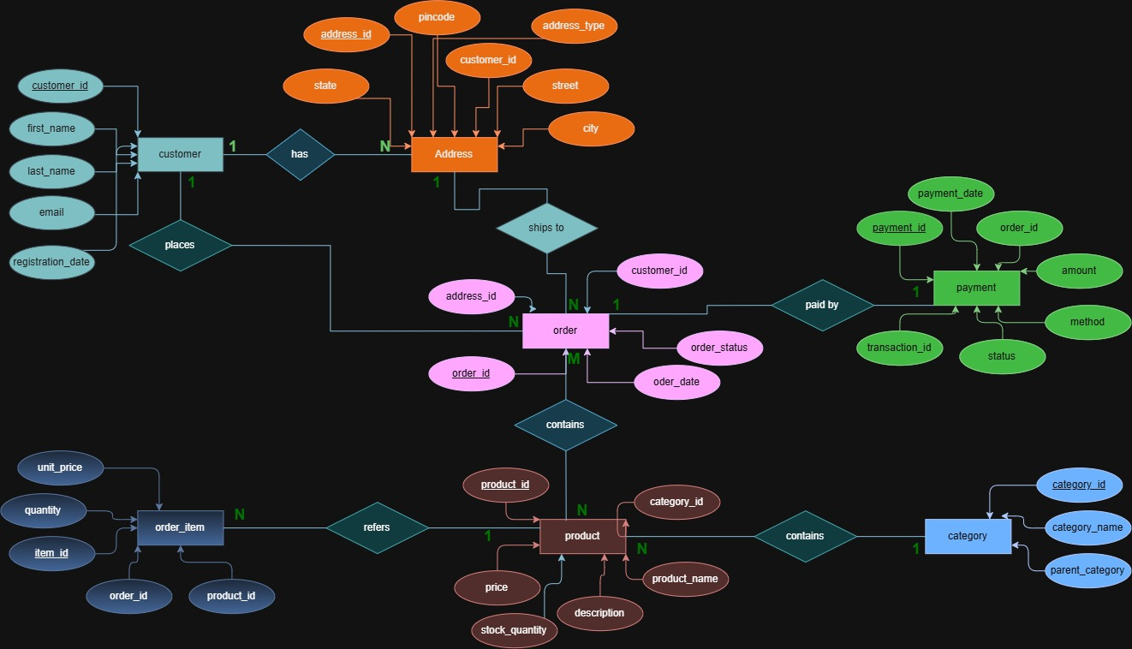

Fig. 3.1: ER Diagram of the e-commerce order management System

3.4 Relationships and Cardinality
Table 3.3: Relationships and Cardinality
Entity 1 | Relationship | Entity 2 | Cardinality (1:1 / 1:N / M:N)
Customer | has | Address | One-to-Many (1:N)
Category | has sub-categories | Category | Self-referencing (1:N)
Product | contains | Category | Many-to-One (N:1)
Customer | places | Order | One-to-Many (1:N)
Order | ships to | Address | Many-to-One (N:1)
Order | contains | Product (via Order_Item) | Many-to-Many (M:N)
Order | paid by | Payment | One-to-One (1:1)
Order_item | refers | Product | Many-to-one(N:1)

3.5 Relational Database Schema

Table 3.4: Relational Database Schema
Table Name | Column Name | Data Type | PK/FK/— | Constraints
Customer | customer_id | INT | PK | PRIMARY KEY AUTO_INCREMENT
 | first_name | VARCHAR(50) | — | NOT NULL
 | last_name | VARCHAR(50) | — | NOT NULL
 | email | VARCHAR(100) | — | UNIQUE NOT NULL
 | registration_date | DATE | — | DEFAULT (CURRENT_DATE)
Address | address_id | INT | PK | PRIMARY KEY AUTO_INCREMENT
 | customer_id | INT | FK | NOT NULL, FOREIGN KEY (customer_id) REFERENCES Customer(customer_id)
 | street | VARCHAR(200) | — | —
 | city | VARCHAR(100) | — | —
 | state | VARCHAR(100) | — | —
 | pincode | VARCHAR(10) | — | —
 | address_type | VARCHAR(20) | — | DEFAULT "Home"
Category | category_id | INT | PK | PRIMARY KEY AUTO_INCREMENT
 | category_name | VARCHAR(100) | — | NOT NULL UNIQUE
 | parent_category_id | INT | FK | FOREIGN KEY (parent_category_id) REFERENCES Category(category_id)
Product | product_id | INT | PK | PRIMARY KEY AUTO_INCREMENT
 | product_name | VARCHAR(200) | — | NOT NULL
 | description | TEXT | — | —
 | price | DECIMAL(10,2) | — | NOT NULL CHECK (price >= 0)
 | stock_quantity | INT | — | DEFAULT 0
 | category_id | INT | FK | FOREIGN KEY (category_id) REFERENCES Category(category_id)
Order | order_id | INT | PK | PRIMARY KEY AUTO_INCREMENT
 | customer_id | INT | FK | NOT NULL, FOREIGN KEY (customer_id) REFERENCES Customer(customer_id)
 | address_id | INT | FK | FOREIGN KEY (address_id) REFERENCES Address(address_id)
 | order_date | DATE | — | DEFAULT (CURRENT_DATE)
 | order_status | VARCHAR(30) | — | DEFAULT "Pending"
Order_Item | item_id | INT | PK | PRIMARY KEY AUTO_INCREMENT
 | order_id | INT | FK | NOT NULL, FOREIGN KEY (order_id) REFERENCES Orders(order_id)
 | product_id | INT | FK | NOT NULL, FOREIGN KEY (product_id) REFERENCES Product(product_id)
 | quantity | INT | — | NOT NULL CHECK (quantity > 0)
 | unit_price | DECIMAL(10,2) | — | NOT NULL
Payment | payment_id | INT | PK | PRIMARY KEY AUTO_INCREMENT
 | order_id | INT | FK | UNIQUE NOT NULL, FOREIGN KEY (order_id) REFERENCES Orders(order_id)
 | payment_date | DATE | — | —
 | amount | DECIMAL(10,2) | — | —
 | method | VARCHAR(30) | — | —
 | status | VARCHAR(20) | — | DEFAULT "Pending"
 | transaction_id | VARCHAR(100) | — | UNIQUE

Schema Diagram
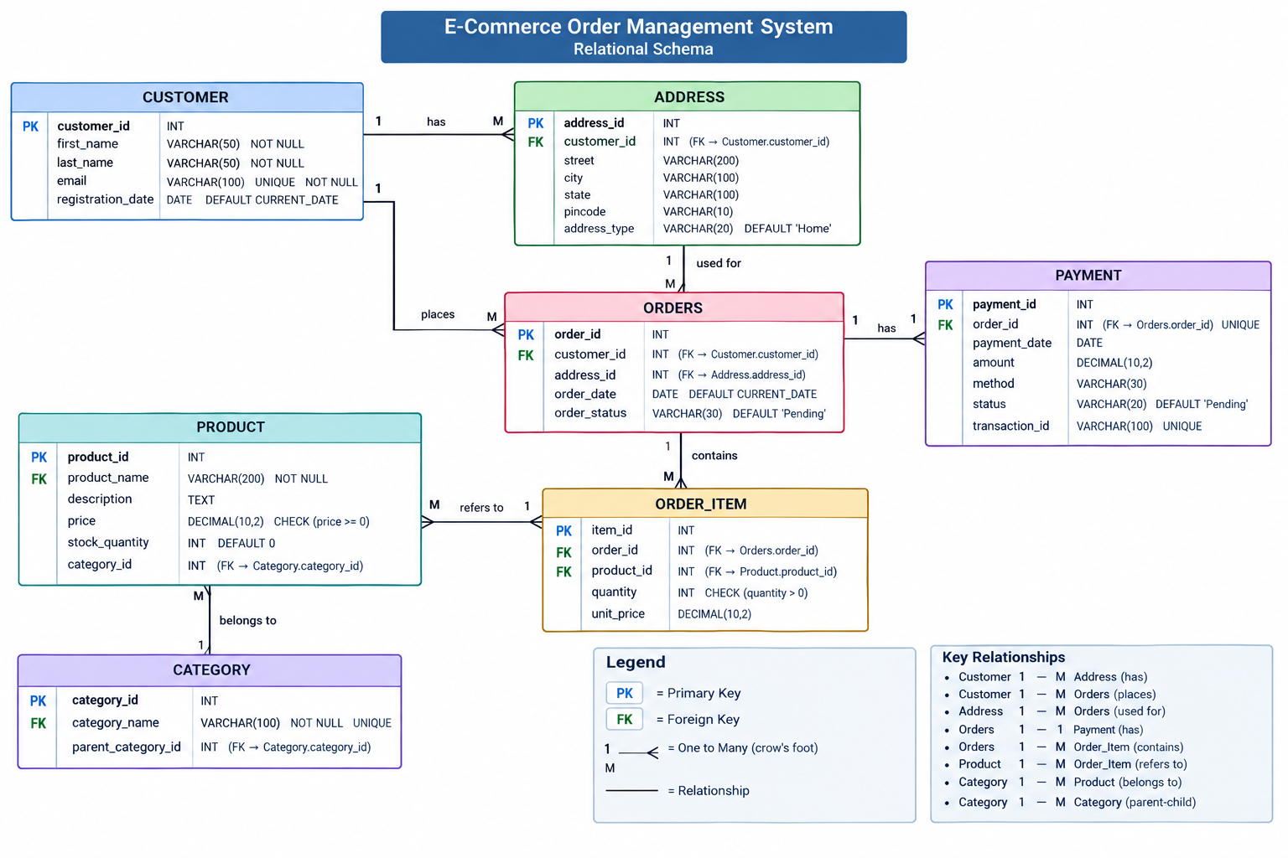

Fig. 3.2: Relational Schema Diagram

3.6 Primary Keys and Foreign Keys
Table 3.5: Primary Key and Foreign Key Definitions
Table | Primary Key | Foreign Key | References (Table.Column)
Customer | customer_id | — | —
Address | address_id | customer_id | Customer(customer_id)
Category | category_id | parent_category_id | Category(category_id)
Product | product_id | category_id | Category(category_id)
Orders | order_id | customer_id, address_id | Customer(customer_id), Address(address_id)
Order_Item | item_id | order_id, product_id | Orders(order_id), Product(product_id)
Payment | payment_id | order_id | Orders(order_id)

3.7 Normalization up to 3NF
Table 3.6: Normalization Steps
Normal Form | Condition Satisfied | Anomaly Removed | Resulting Tables
UNF  (Unnormalized Form) | Contains nested or repeating groups of attributes (e.g., storing multiple order items and addresses inside a single flat record). | High data redundancy, difficult data retrieval, and complex querying. | Single flattened table containing all e-commerce data (Unnormalized_Order_Data).
1NF  (First Normal Form) | All attributes contain atomic (indivisible) values, and each table has a primary key with no repeating groups. | Eliminates repeating groups and multi-valued attributes, ensuring each cell holds a single value. | Customer, Address, Category, Product, Orders, Order_Item, Payment (with atomized fields).
2NF  (Second Normal Form) | The relation is in 1NF and all non-key attributes are fully functionally dependent on the entire primary key (no partial dependencies). | Partial Dependency Update Anomaly: Removes situations where non-key attributes depend only on part of a composite primary key. | Separates composite entities cleanly, establishing proper foreign key lookup paths between parent and child tables.
3NF  (Third Normal Form) | The relation is in 2NF and has no transitive dependencies (i.e., non-key attributes do not depend on other non-key attributes). | Transitive Dependency Anomaly: Prevents inconsistencies where changing a non-key attribute (like category description) requires updating multiple product rows. | Refined tables (Customer, Address, Category, Product, Orders, Order_Item, Payment) where every non-key column depends only on the primary key.

CHAPTER 4: DATABASE IMPLEMENTATION
(Deliverables of Review – II)

4.1 Database and Table Creation – DDL
CREATE TABLE Customer (
customer_id INT PRIMARY KEY,
first_name VARCHAR(50) NOT NULL,
last_name VARCHAR(50) NOT NULL,
email VARCHAR(100) UNIQUE NOT NULL,
registration_date DATE DEFAULT (CURRENT_DATE)
);

CREATE TABLE Address (
address_id INT PRIMARY KEY,
customer_id INT NOT NULL,
street VARCHAR(200),
city VARCHAR(100),
state VARCHAR(100),
pincode VARCHAR(10),
address_type VARCHAR(20) DEFAULT 'Home',
FOREIGN KEY (customer_id) REFERENCES Customer(customer_id)
);

CREATE TABLE Category (
category_id INT PRIMARY KEY,
category_name VARCHAR(100) NOT NULL UNIQUE,
parent_category_id INT,
FOREIGN KEY (parent_category_id) REFERENCES Category(category_id)
);

CREATE TABLE Product (
product_id INT PRIMARY KEY ,
product_name VARCHAR(200) NOT NULL,
description TEXT,
price DECIMAL(10,2) NOT NULL CHECK (price >= 0),
stock_quantity INT DEFAULT 0,
category_id INT,
FOREIGN KEY (category_id) REFERENCES Category(category_id)
);

CREATE TABLE Orders (
order_id INT PRIMARY KEY,
customer_id INT NOT NULL,
address_id INT,
order_date DATE DEFAULT (CURRENT_DATE),
order_status VARCHAR(30) DEFAULT 'Pending',
FOREIGN KEY (customer_id) REFERENCES Customer(customer_id),
FOREIGN KEY (address_id) REFERENCES Address(address_id)
);

CREATE TABLE Order_Item (
item_id INT PRIMARY KEY ,
order_id INT NOT NULL,
product_id INT NOT NULL,
quantity INT NOT NULL CHECK (quantity > 0),
unit_price DECIMAL(10,2) NOT NULL,
FOREIGN KEY (order_id) REFERENCES Orders(order_id),
FOREIGN KEY (product_id) REFERENCES Product(product_id)
);

CREATE TABLE Payment (
payment_id INT PRIMARY KEY ,
order_id INT UNIQUE NOT NULL,
payment_date DATE,
amount DECIMAL(10,2),
method VARCHAR(30),
status VARCHAR(20) DEFAULT 'Pending',
transaction_id VARCHAR(100) UNIQUE,
FOREIGN KEY (order_id) REFERENCES Orders(order_id)
);

Tables_in ecommerce order management system
Customer
Address
Category
Product
Orders
Order_item
Payment

Fig. 4.1: Successful Creation of Tables

4.2 Sample Data Insertion – DML
Fig. 4.2: Sample Data Inserted into the Tables

Table | No. of Records | Sample Data / Screenshot Reference
Customer | 15 | 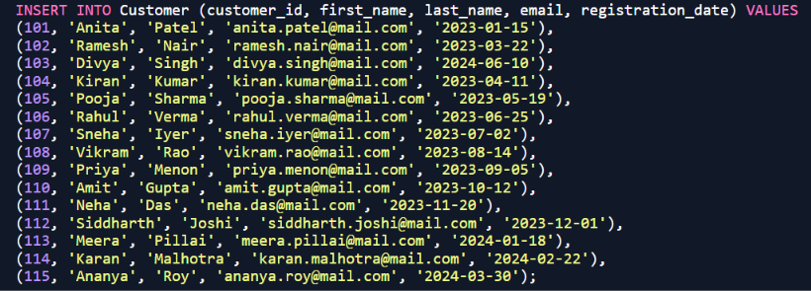
Address | 15 | 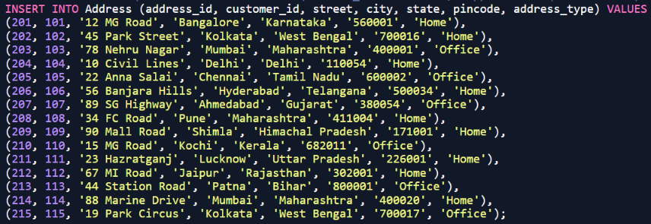
Category | 15 | 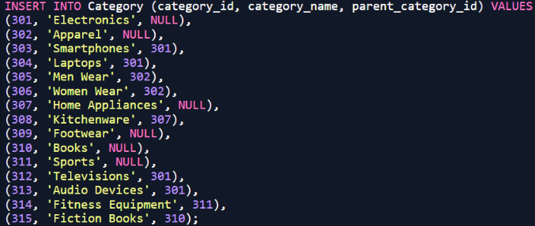
product | 15 | 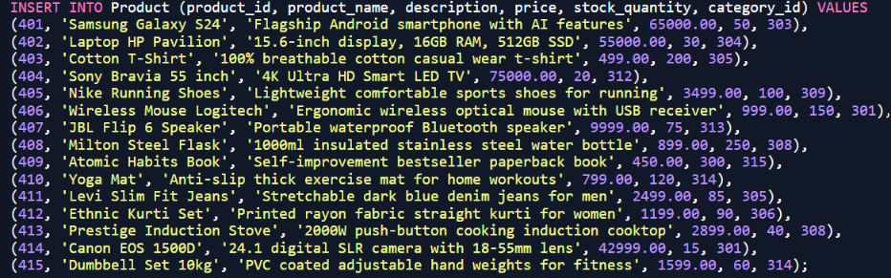
Orders | 15 | 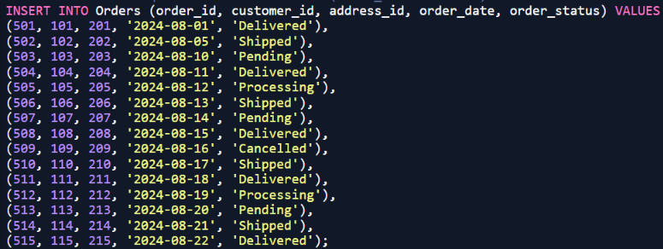
Order_item | 15 | 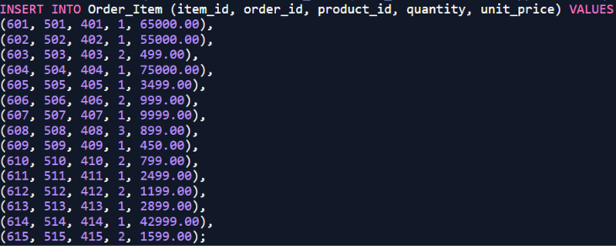
Payment | 15 | 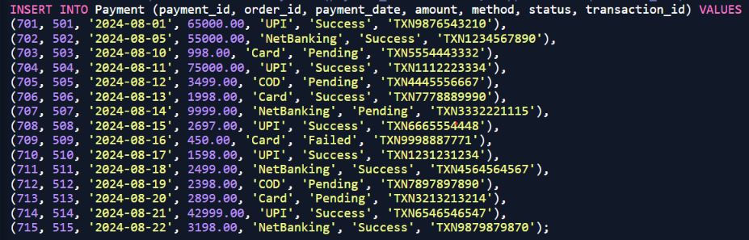

4.3 Constraints and Data Integrity
Table 4.2: Constraints and Data Integrity Rules

Constraint / Validation | Applied On | Purpose
PRIMARY KEY | All seven tables (Customer, Address, Category, Product, Orders, Order_Item, Payment) | Uniquely identifies each row; prevents duplicate records
UNIQUE | Customer.email, Category.category_name, Payment.transaction_id, Payment.order_id | Prevents two customers, categories, or transactions sharing an identity or tracking value
UNIQUE (composite) | Order_Item(order_id, product_id) | Stops the same product from being duplicated as a separate line item entry within the same order context
NOT NULL | Names, emails, prices, quantities, and all foreign key columns across the schema | Ensures mandatory operational information is always supplied during record creation
CHECK | Product.price >= 0, Product.stock_quantity >= 0, Order_Item.quantity > 0, Payment.amount >= 0 | Keeps financial and quantitative values within permitted logical ranges
CHECK | Address.address_type IN ('Home', 'Office', 'Other'), Orders.order_status IN (...), Payment.method IN (...) | Restricts string inputs to predefined allowable system states
DEFAULT | Customer.registration_date, Address.address_type, Product.stock_quantity, Orders.order_status | Supplies standard operational defaults (e.g., current date, 'Home', 'Pending') when omitted
FOREIGN KEY | Seven relational links across the schema (Customer-Address, Category-Product, Customer-Orders, etc.) | Prevents orphan records and maintains strict referential integrity
ON DELETE CASCADE | Address.customer_id, Order_Item.order_id, Payment.order_id | Removes dependent child records automatically when a parent order or customer is deleted

4.4 Data Validation Rules

Here is the demonstration of three invalid statements executed deliberately on our E-Commerce Order Management System schema running on DB Fiddle, where the database rejected each statement and no row was inserted:

(a) Referential integrity — order placement for a customer ID that does not exist:

SQL
INSERT INTO Orders (order_id, customer_id, address_id, order_date, order_status)
VALUES (516, 999, 201, '2024-08-25', 'Pending');
Plaintext
ERROR: insert or update on table "orders" violates foreign key constraint "orders_customer_id_fkey"
DETAIL: Key (customer_id)=(999) is not present in table "customer".

(b) CHECK constraint — a negative product price:
SQL
INSERT INTO Product (product_id, product_name, description, price, stock_quantity, category_id)
VALUES (416, 'Faulty Item', 'Test product with negative price', -150.00, 10, 301);
Plaintext
ERROR: new row for relation "product" violates check constraint "product_price_check"
DETAIL: Failing row contains (416, Faulty Item, Test product with negative price, -150.00, 10, 301).

(c) UNIQUE constraint — a duplicate customer email address:
SQL
INSERT INTO Customer (customer_id, first_name, last_name, email, registration_date)
VALUES (116, 'Test', 'User', 'anita.patel@mail.com', '2026-06-01');
Plaintext
ERROR: duplicate key value violates unique constraint "customer_email_key"
DETAIL: Key (email)=(anita.patel@mail.com) already exists.

These three results confirm that invalid data is rejected by the database engine itself and does not depend on the application or on the person entering the data.

CHAPTER 5: SQL OPERATIONS AND QUERIES

5.1 DQL – Basic Retrieval Queries
Q1: Retrieve all customer details who registered in or after the year 2024.
SELECT * FROM Customer WHERE registration_date >= '2024-01-01';
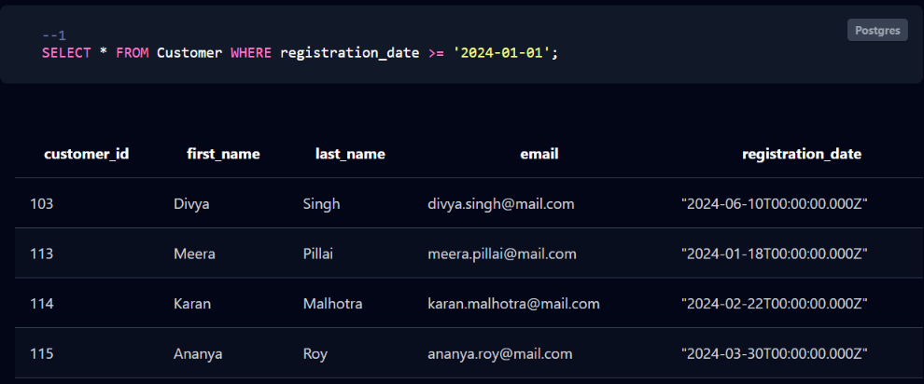
Q2: Fetch product names, prices, and quantities where stock is less than 50 units.
SELECT product_name, price, stock_quantity FROM Product WHERE stock_quantity < 50;
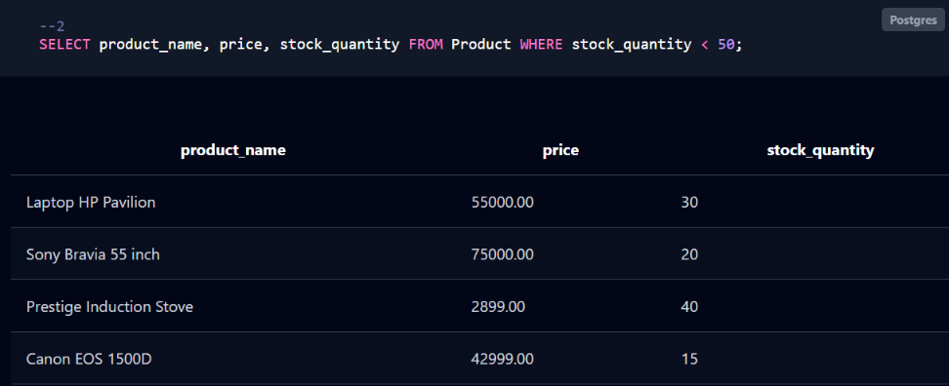
Q3: Retrieve all distinct payment methods used across customer transactions.
SELECT DISTINCT method FROM Payment;
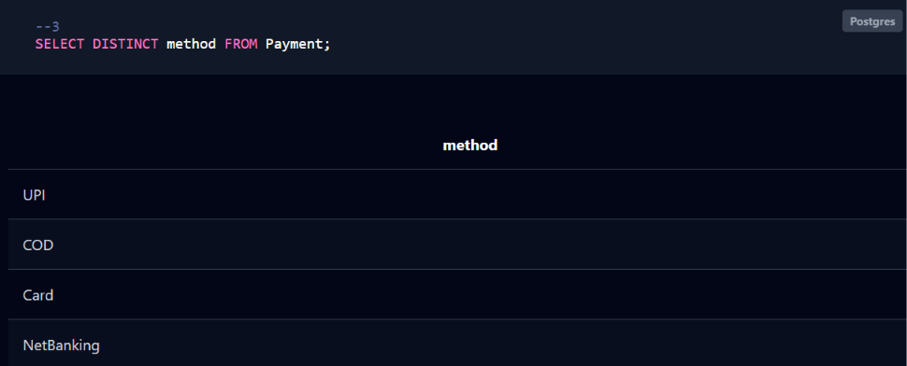

5.2 Join Operations

Q4: Inner Join: List order IDs, customer first names, dates, and status which have delivered status .
SELECT o.order_id, c.first_name, o.order_date, o.order_status
FROM Orders o INNER JOIN Customer c ON o.customer_id = c.customer_id
WHERE order_status=’Delivered’;
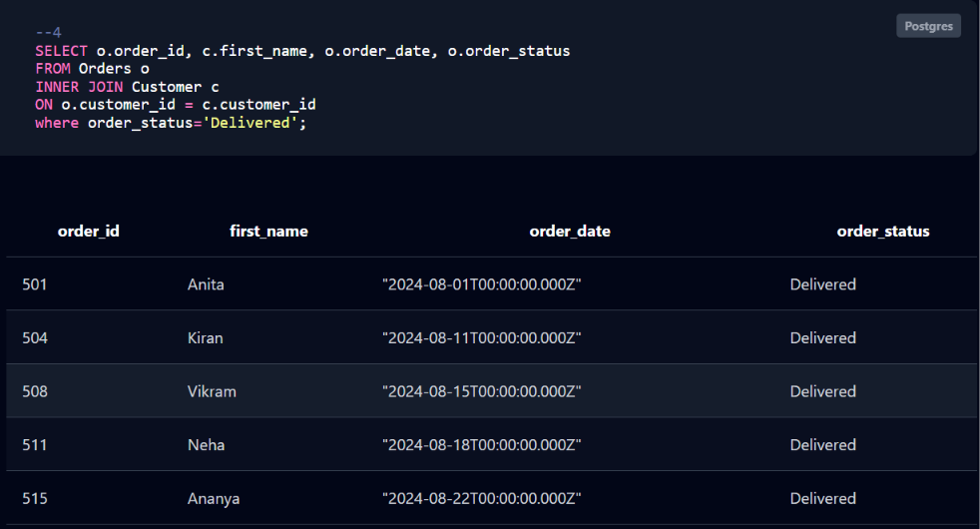

Q5: Left Outer Join: Display all product categories having category_name laptops and their matching products.
SELECT c.category_name, p.product_name
FROM Category c LEFT JOIN Product p ON c.category_id = p.category_id
WHERE category_name=’Laptops’;
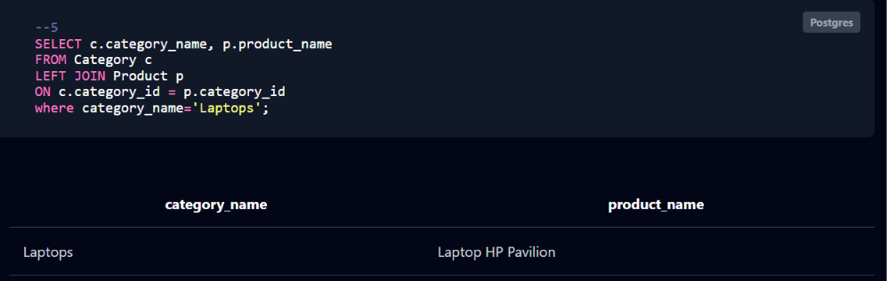
Q6: Right Outer Join: Retrieve all payments having status Pending aligned with their parent order references.
SELECT o.order_id, p.payment_id, p.amount, p.status
FROM Orders o RIGHT JOIN Payment p ON o.order_id = p.order_id
WHERE status=’Pending’;
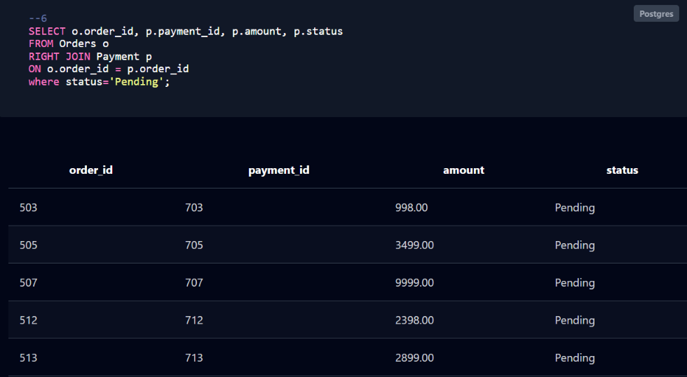
Q7: Full Outer Join: Combine customer names and cities having name Delhi across both tables.
SELECT c.first_name, a.city
FROM Customer c FULL OUTER JOIN Address a ON c.customer_id = a.customer_id
WHERE city=’Delhi’;
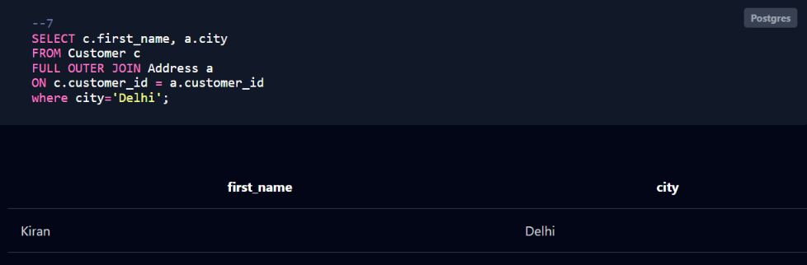

5.3 Aggregate Functions, GROUP BY and HAVING

Q8: Calculate total revenue generated from all successful payments.
SELECT SUM(amount) AS total_revenue FROM Payment WHERE status = 'Success';
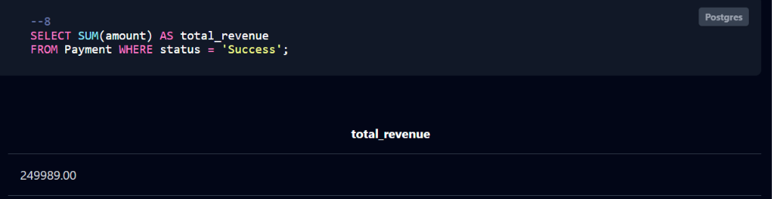

Q9: Count the total number of transactions grouped by each payment method.
SELECT method, COUNT(*) AS transaction_count FROM Payment GROUP BY method;
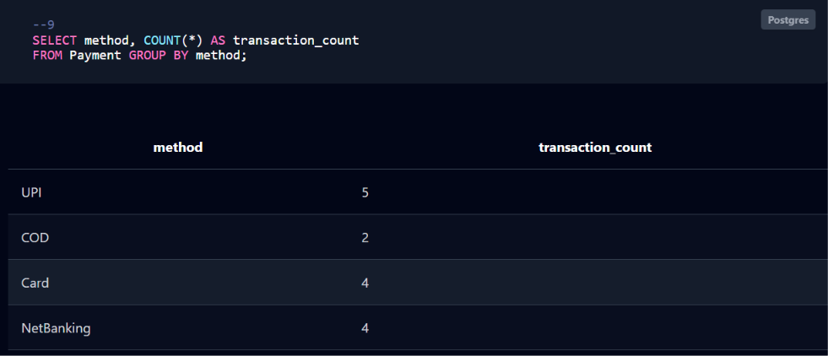

Q10: Find categories where the average product price exceeds $5,000.
SELECT category_id, AVG(price) AS avg_price FROM Product GROUP BY category_id HAVING AVG(price) > 5000;
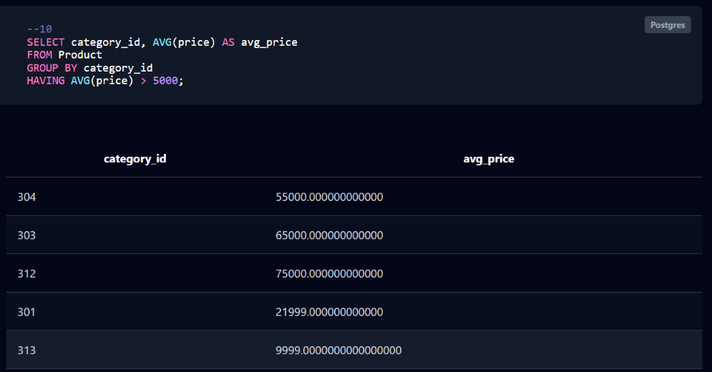

5.4 Nested and Correlated Subqueries

Q11: Nested Subquery: Find products priced above the overall catalog average.
SELECT product_name, price FROM Product WHERE price > (SELECT AVG(price) FROM Product);
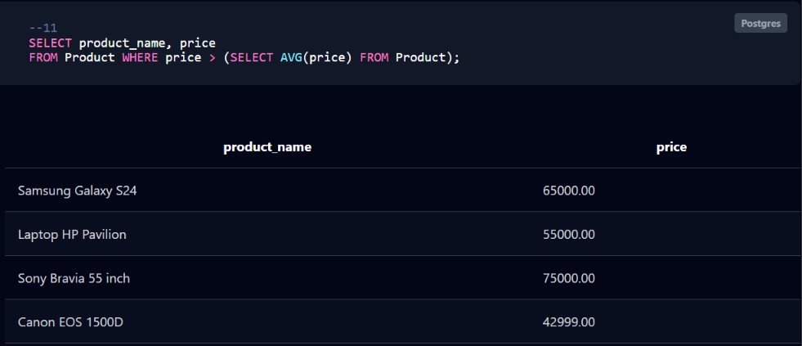
Q12: Correlated Subquery: Find products priced higher than their specific category average.
SELECT p.product_name, p.price, p.category_id
FROM Product p
WHERE p.price > (SELECT AVG(sub.price)
FROM Product sub WHERE sub.category_id = p.category_id);
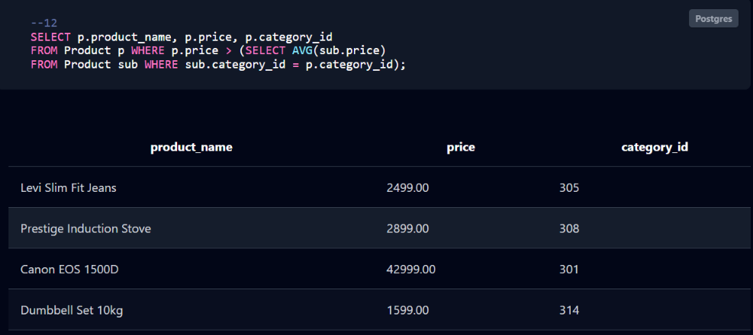

5.5 Views and Relational Set Operations

Q13: Create an updatable view for the product catalog.
CREATE VIEW ProductCatalog AS
SELECT product_id, product_name, price, stock_quantity FROM Product;

Q14: Create a non-updatable aggregate summary view for categories.
CREATE VIEW CategorySales AS
SELECT category_id, COUNT(*) AS total_products, AVG(price) AS avg_price
FROM Product GROUP BY category_id;

Q15: Set Operation (UNION): Combine unique cities from Maharashtra and West Bengal.
SELECT city FROM Address WHERE state = 'Maharashtra'
UNION
SELECT city FROM Address WHERE state = 'West Bengal';
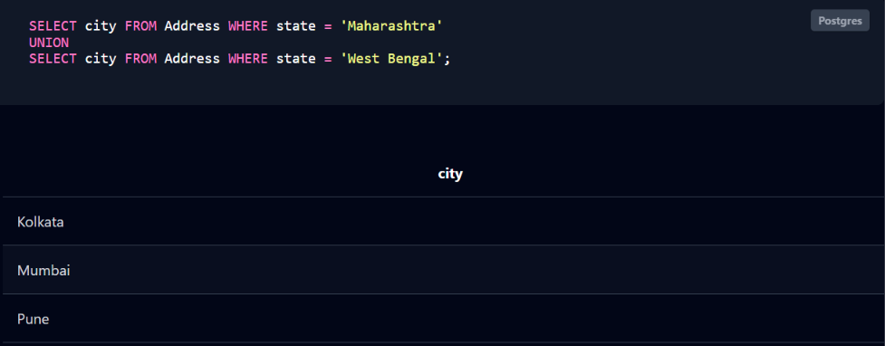

Q16: Set Operation (EXCEPT): List customer IDs who have never placed a cancelled order.
SELECT customer_id FROM Customer
EXCEPT
SELECT customer_id FROM Orders WHERE order_status = 'Cancelled';
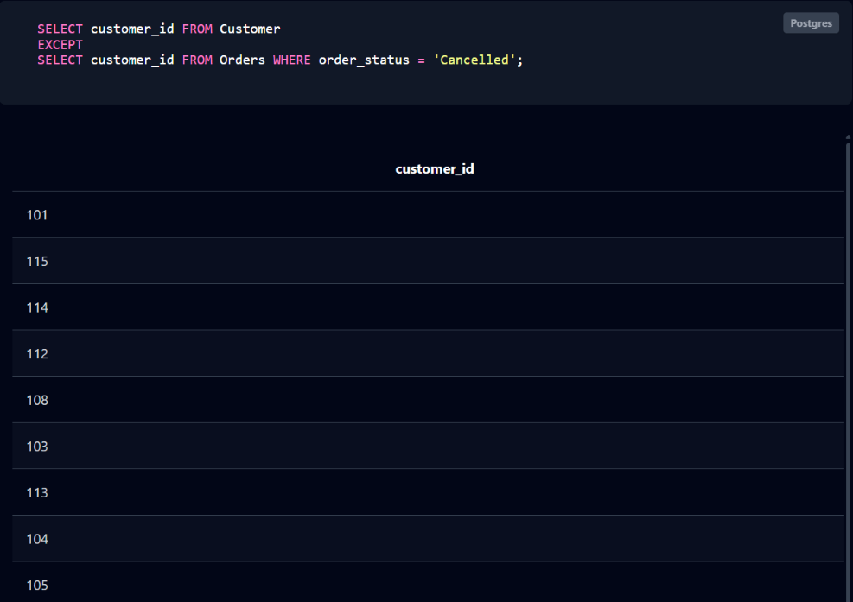

5.6 DCL and TCL Operations

Q17: GRANT (DCL): Grant SELECT and INSERT privileges on Product to a user role.
GRANT SELECT, INSERT ON Product TO sales_user;

Q18: REVOKE (DCL): Revoke INSERT privileges on Product from a user role.
REVOKE INSERT ON Product FROM sales_user;

Q19: COMMIT (TCL): Permanently save changes made during the current transaction.
BEGIN TRANSACTION;
UPDATE Product SET stock_quantity = 45 WHERE product_id = 401;
COMMIT;

Q20: SAVEPOINT (TCL): Set an intermediate rollback checkpoint within a transaction block.
BEGIN TRANSACTION;
INSERT INTO Customer VALUES (116, 'Test', 'User', 'test@mail.com', '2026-06-01');
SAVEPOINT sp1;

Q21: ROLLBACK (TCL): Revert database state back to a specified savepoint after an error.
ROLLBACK TO sp1;
COMMIT;

CHAPTER 6: MODULES AND FUNCTIONALITIES
S.No | Module Name | Functionality
1 | Customer Module | Manages user account profiles, registration data, personal details, and links individual buyers to their contact emails and identities.
2 | Address Module | Stores and manages delivery locations associated with customers (such as home or office addresses), ensuring correct shipping routing.
3 | Product & Category Module | Organizes the inventory catalog into hierarchical categories and tracks individual items along with descriptions, pricing, and stock levels.
4 | Order Management Module | Handles shopping transactions by recording order placements, tracking live statuses (Pending, Shipped, Delivered), and mapping items to purchases.
5 | Payment & Transaction Module | Processes financial transactions across various methods (UPI, Card, NetBanking, COD), tracking success/failure states and secure transaction IDs.

CHAPTER 7: RESULTS – SAMPLE OUTPUTS AND SCREENSHOTS

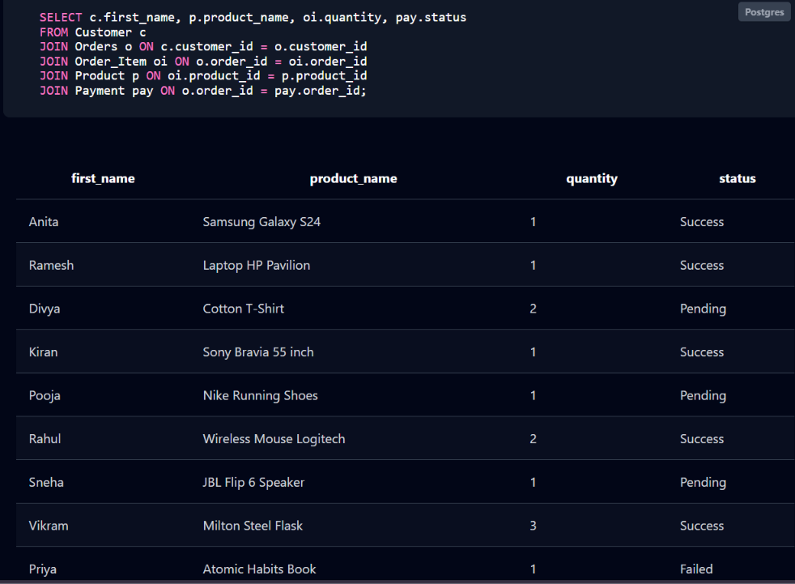

Fig. 7.1: SELECT c.first_name, p.product_name, oi.quantity, pay.status
FROM Customer c
JOIN Orders o ON c.customer_id = o.customer_id
JOIN Order_Item oi ON o.order_id = oi.order_id
JOIN Product p ON oi.product_id = p.product_id
JOIN Payment pay ON o.order_id = pay.order_id;

CHAPTER 8: TESTING AND DATA VALIDATION

Table 8.1: Test Cases and Results

TC | Test Case Description | Input / Action | Expected Result | Status
TC-01 | Primary key uniqueness | Insert Customer with existing customer_id 101 | Duplicate entry error | Pass
TC-02 | Unique email | Insert Customer with an existing email | Duplicate key error / unique violation | Pass
TC-03 | NOT NULL enforcement | Insert Customer without first_name | Column cannot be null error | Pass
TC-04 | CHECK on price | Insert Product with price = -150.00 | Check constraint violated error | Pass
TC-05 | CHECK on quantity | Insert Order_Item with quantity = 0 | Check constraint violated error | Pass
TC-06 | Referential integrity (child) | Insert Orders with non-existent customer_id 999 | Foreign key violation error | Pass
TC-07 | Referential integrity (parent) | Delete Customer 101 who has active orders | Delete rejected by foreign key restriction | Pass
TC-08 | Composite unique key / mapping | Insert duplicate product entry within the same order context | Unique constraint or duplicate entry error | Pass
TC-09 | 1:1 Order–Payment relationship | Insert a second Payment row for the same order_id | Unique constraint error on order_id | Pass
TC-10 | DEFAULT value | Insert Orders without specifying order_status | order_status stored as 'Pending' automatically | Pass
TC-11 | ON DELETE CASCADE | Delete Customer 101 (with CASCADE configuration) | Matching Address rows removed automatically | Pass
TC-12 | Query correctness | Execute Q10 (HAVING average price > 5000) | Returns high-value product categories as expected | Pass
Test cases TC-01 to TC-11 verify that the database itself refuses invalid data, so the integrity of the e-commerce records does not depend on the care of the person entering them. TC-12 verifies that the aggregate and join queries return the expected rows against the known sample data.

CHAPTER 9: GITHUB REPOSITORY AND TEAM CONTRIBUTION

9.1 Repository Details
GitHub Repository Link: ______________________________________________________
The final SQL script and all project files must be pushed to the team repository.

9.2 Team Responsibilities and Contribution
Table 9.1: Team Responsibilities
S.No | Student Name | Roll Number | Role / Responsibility | Modules Contributed

9.3 Review-wise Progress
Table 9.2: Review-wise Progress Record
Review | Date | Deliverables Presented | Remarks of the Guide

CHAPTER 10: CONCLUSION AND FUTURE ENHANCEMENTS

10.1 Conclusion
Here is a comprehensive summary of the project outcomes based on the E-Commerce Order Management System implementation:

1. Database Design & Architecture
- Core Entities & Tables: The database architecture successfully incorporates 7 distinct core entities and tables: Customer, Address, Category, Product, Orders, Order_Item, and Payment.

- Unique ID Range Isolation: Data integrity was rigorously maintained during populating by establishing unique, non-overlapping primary key blocks for each table to completely avoid duplicate or conflicting key constraints (e.g., Customer IDs 101–115, Address IDs 201–215, Category IDs 301–315, Product IDs 401–415, Order IDs 501–515, Order Item IDs 601–615, and Payment IDs 701–715).

- Normalization Achieved: The schema adheres to Third Normal Form (3NF) principles. Redundancy was systematically eliminated by separating attributes into logical domains—for instance, isolating customer demographics, distinct multi-address shipping types, self-referential parent-child product categories, order headers, granular order line items, and independent transaction records—linked cleanly via Foreign Keys.

2. SQL Operations Implemented
The project successfully deployed a robust full-spectrum set of SQL operations and database functionalities:

- DDL (Data Definition Language): Defined the strict schema layout using explicit CREATE TABLE constraints, data types, Primary Keys, and Foreign Key references.

- DML (Data Manipulation Language) & CRUD: Executed controlled insert scripts containing 15 unique, verified sample records per table, alongside data retrieval, stock quantity updates, and operational record tracking.

- Advanced Queries & Joins: Implemented complex multi-table INNER JOIN operations bridging Orders, Customer, and Payment datasets.

- Aggregations, Grouping, & Subqueries: Leveraged aggregate functions (SUM, COUNT, AVG) coupled with GROUP BY / HAVING clauses and nested subqueries to extract meaningful operational insights (e.g., total sales revenue tracking).

- Views: Created reusable virtual tables (VIEW) to simplify complex reporting workflows across multi-table transactional linkages.

3. Meeting Project Objectives
Each primary objective set out for the system was achieved through systematic phase execution:

- Objective 1: Relational Schema & Integrity: Met by establishing strict primary and foreign key constraints, preventing orphaned data records across orders, payments, and shipping addresses.

- Objective 2: Scalable Data Population: Met by generating clean, realistic test inputs (spanning 15 unique records per entity) that validate correct functioning under multi-row relational queries.

- Objective 3: Analytical & Transactional Reporting: Met by building a comprehensive suite of queries—ranging from basic CRUD loops to high-level aggregate reporting and view abstractions—proving the database's readiness for real-world e-commerce administration.

10.2 Limitations of the Present Work
While the E-Commerce Order Management System is robust for core transactional workflows, it has several limitations and explicitly does not handle the following advanced features and scenarios:

- Real-Time Inventory Warehousing & Multi-Location Stock Tracking: The system tracks a static stock_quantity field at the product level, but it does not support dynamic inventory allocation across multiple physical warehouses, backorders, automated reordering thresholds, or real-time supplier stock syncs.

- Returns, Refunds, and Exchanges (Reverse Logistics): There are no database entities or workflow states designed to handle product returns, item replacements, refund transaction tracking, or reverse shipping logistics. Orders only move forward through a linear lifecycle (Pending to Delivered/Cancelled).

- Advanced Tax & Shipping Calculations: The database stores raw amounts and prices but lacks dynamic tax jurisdiction rules, regional shipping rate calculations, weight-based postal costs, or handling charges.

- Third-Party Payment Gateway Integration & Webhooks: While payments are logged via fields like transaction_id and status, the schema does not manage real-time payment gateway tokens, partial refunds, multi-currency conversions, split payments, or webhook error logging from gateways like Stripe or Razorpay.

- Customer Relationship Management (CRM) & Marketing: The system does not track user sessions, cart abandonment histories, product reviews/ratings, wishlists, discount coupons, promotional voucher redemptions, or loyalty rewards programs.

- Concurrency & Inventory Race Conditions: While relational constraints handle structural data integrity, the current schema and basic SQL setup lack built-in row-level locking mechanisms, optimistic concurrency control, or transactional isolation scripts to prevent race conditions during high-traffic flash sales (e.g., simultaneous checkouts drawing from the last remaining stock item).

10.3 Future Enhancements

Here are the planned enhancements and future improvements for the E-Commerce Order Management System:

- Additional Modules: Introduce dedicated modules for Inventory Management (tracking warehouse stocks and low-stock alerts) and Reverse Logistics (handling returns, refunds, and replacements).

- Front-End Application: Develop a modern, responsive web and mobile user interface using React or Next.js to provide seamless user interaction, shopping carts, and dynamic order tracking.

- Stored Procedures and Triggers: Implement automated backend logic using stored procedures for order checkout transactions and triggers to automatically update product stock_quantity whenever an order item is placed.

- Indexing for Performance: Add performance-boosting B-tree indexes on frequently queried columns such as customer email addresses, product names, and order foreign keys to speed up search and join operations.

- Security and Access Control: Establish role-based access control (RBAC) to restrict database privileges, along with password hashing and secure token-based authentication (OAuth2) for API layers.

- Backup and Recovery: Set up automated daily database backup routines, point-in-time recovery configurations, and disaster recovery replication policies to ensure business continuity.

- Reporting and Analytics: Build a comprehensive business intelligence (BI) reporting layer with analytical views and dashboards to track sales trends, customer lifetime value, and peak purchasing periods.

REFERENCES
- Abraham Silberschatz, Henry F. Korth and S. Sudarshan, “Database System Concepts”, 8th Edition, McGraw-Hill, ISBN: 978-1260230508.
- Raghurama Krishnan and Johannes Gehrke, “Database Management Systems”, 4th Edition, McGraw-Hill, ISBN: 978-1260091195.
- Ramez Elmasri and Shamkant B. Navathe, “Fundamentals of Database Systems”, 7th Edition, Pearson, ISBN: 978-0137504277.

APPENDIX A – COMPLETE SQL SCRIPT
-- =========================================================================
-- 1. DATABASE CREATION AND SCHEMA DEFINITION WITH CONSTRAINTS
-- =========================================================================

CREATE DATABASE EcommerceDB;
-- \c EcommerceDB; -- Use this command in PostgreSQL to connect if running via terminal

-- Customer Table
CREATE TABLE Customer (
customer_id INT PRIMARY KEY,
first_name VARCHAR(50) NOT NULL,
last_name VARCHAR(50) NOT NULL,
email VARCHAR(100) UNIQUE NOT NULL,
registration_date DATE DEFAULT (CURRENT_DATE)
);

-- Address Table
CREATE TABLE Address (
address_id INT PRIMARY KEY,
customer_id INT NOT NULL,
street VARCHAR(200) NOT NULL,
city VARCHAR(100) NOT NULL,
state VARCHAR(100) NOT NULL,
pincode VARCHAR(10) NOT NULL,
address_type VARCHAR(20) DEFAULT 'Home' CHECK (address_type IN ('Home', 'Office', 'Other')),
FOREIGN KEY (customer_id) REFERENCES Customer(customer_id) ON DELETE CASCADE
);

-- Category Table
CREATE TABLE Category (
category_id INT PRIMARY KEY,
category_name VARCHAR(100) NOT NULL UNIQUE,
parent_category_id INT,
FOREIGN KEY (parent_category_id) REFERENCES Category(category_id) ON DELETE SET NULL
);

-- Product Table
CREATE TABLE Product (
product_id INT PRIMARY KEY,
product_name VARCHAR(200) NOT NULL,
description TEXT,
price DECIMAL(10,2) NOT NULL CHECK (price >= 0),
stock_quantity INT NOT NULL DEFAULT 0 CHECK (stock_quantity >= 0),
category_id INT,
FOREIGN KEY (category_id) REFERENCES Category(category_id) ON DELETE SET NULL
);

-- Orders Table
CREATE TABLE Orders (
order_id INT PRIMARY KEY,
customer_id INT NOT NULL,
address_id INT NOT NULL,
order_date DATE DEFAULT (CURRENT_DATE),
order_status VARCHAR(30) DEFAULT 'Pending' CHECK (order_status IN ('Pending', 'Processing', 'Shipped', 'Delivered', 'Cancelled')),
FOREIGN KEY (customer_id) REFERENCES Customer(customer_id) ON DELETE RESTRICT,
FOREIGN KEY (address_id) REFERENCES Address(address_id) ON DELETE RESTRICT
);

-- Order_Item Table
CREATE TABLE Order_Item (
item_id INT PRIMARY KEY,
order_id INT NOT NULL,
product_id INT NOT NULL,
quantity INT NOT NULL CHECK (quantity > 0),
unit_price DECIMAL(10,2) NOT NULL CHECK (unit_price >= 0),
FOREIGN KEY (order_id) REFERENCES Orders(order_id) ON DELETE CASCADE,
FOREIGN KEY (product_id) REFERENCES Product(product_id) ON DELETE RESTRICT
);

-- Payment Table
CREATE TABLE Payment (
payment_id INT PRIMARY KEY,
order_id INT UNIQUE NOT NULL,
payment_date DATE DEFAULT (CURRENT_DATE),
amount DECIMAL(10,2) NOT NULL CHECK (amount >= 0),
method VARCHAR(30) NOT NULL CHECK (method IN ('UPI', 'Card', 'NetBanking', 'COD')),
status VARCHAR(20) DEFAULT 'Pending' CHECK (status IN ('Pending', 'Success', 'Failed')),
transaction_id VARCHAR(100) UNIQUE NOT NULL,
FOREIGN KEY (order_id) REFERENCES Orders(order_id) ON DELETE CASCADE
);

-- =========================================================================
-- 2. SAMPLE DATA INSERTION (15 UNIQUE RECORDS PER TABLE)
-- =========================================================================

INSERT INTO Customer (customer_id, first_name, last_name, email, registration_date) VALUES
(101, 'Anita', 'Patel', 'anita.patel@mail.com', '2023-01-15'),
(102, 'Ramesh', 'Nair', 'ramesh.nair@mail.com', '2023-03-22'),
(103, 'Divya', 'Singh', 'divya.singh@mail.com', '2024-06-10'),
(104, 'Kiran', 'Kumar', 'kiran.kumar@mail.com', '2023-04-11'),
(105, 'Pooja', 'Sharma', 'pooja.sharma@mail.com', '2023-05-19'),
(106, 'Rahul', 'Verma', 'rahul.verma@mail.com', '2023-06-25'),
(107, 'Sneha', 'Iyer', 'sneha.iyer@mail.com', '2023-07-02'),
(108, 'Vikram', 'Rao', 'vikram.rao@mail.com', '2023-08-14'),
(109, 'Priya', 'Menon', 'priya.menon@mail.com', '2023-09-05'),
(110, 'Amit', 'Gupta', 'amit.gupta@mail.com', '2023-10-12'),
(111, 'Neha', 'Das', 'neha.das@mail.com', '2023-11-20'),
(112, 'Siddharth', 'Joshi', 'siddharth.joshi@mail.com', '2023-12-01'),
(113, 'Meera', 'Pillai', 'meera.pillai@mail.com', '2024-01-18'),
(114, 'Karan', 'Malhotra', 'karan.malhotra@mail.com', '2024-02-22'),
(115, 'Ananya', 'Roy', 'ananya.roy@mail.com', '2024-03-30');

INSERT INTO Address (address_id, customer_id, street, city, state, pincode, address_type) VALUES
(201, 101, '12 MG Road', 'Bangalore', 'Karnataka', '560001', 'Home'),
(202, 102, '45 Park Street', 'Kolkata', 'West Bengal', '700016', 'Home'),
(203, 103, '78 Nehru Nagar', 'Mumbai', 'Maharashtra', '400001', 'Office'),
(204, 104, '10 Civil Lines', 'Delhi', 'Delhi', '110054', 'Home'),
(205, 105, '22 Anna Salai', 'Chennai', 'Tamil Nadu', '600002', 'Office'),
(206, 106, '56 Banjara Hills', 'Hyderabad', 'Telangana', '500034', 'Home'),
(207, 107, '89 SG Highway', 'Ahmedabad', 'Gujarat', '380054', 'Office'),
(208, 108, '34 FC Road', 'Pune', 'Maharashtra', '411004', 'Home'),
(209, 109, '90 Mall Road', 'Shimla', 'Himachal Pradesh', '171001', 'Home'),
(210, 110, '15 MG Road', 'Kochi', 'Kerala', '682011', 'Office'),
(211, 111, '23 Hazratganj', 'Lucknow', 'Uttar Pradesh', '226001', 'Home'),
(212, 112, '67 MI Road', 'Jaipur', 'Rajasthan', '302001', 'Home'),
(213, 113, '44 Station Road', 'Patna', 'Bihar', '800001', 'Office'),
(214, 114, '88 Marine Drive', 'Mumbai', 'Maharashtra', '400020', 'Home'),
(215, 115, '19 Park Circus', 'Kolkata', 'West Bengal', '700017', 'Office');

INSERT INTO Category (category_id, category_name, parent_category_id) VALUES
(301, 'Electronics', NULL),
(302, 'Apparel', NULL),
(303, 'Smartphones', 301),
(304, 'Laptops', 301),
(305, 'Men Wear', 302),
(306, 'Women Wear', 302),
(307, 'Home Appliances', NULL),
(308, 'Kitchenware', 307),
(309, 'Footwear', NULL),
(310, 'Books', NULL),
(311, 'Sports', NULL),
(312, 'Televisions', 301),
(313, 'Audio Devices', 301),
(314, 'Fitness Equipment', 311),
(315, 'Fiction Books', 310);

INSERT INTO Product (product_id, product_name, description, price, stock_quantity, category_id) VALUES
(401, 'Samsung Galaxy S24', 'Flagship Android smartphone with AI features', 65000.00, 50, 303),
(402, 'Laptop HP Pavilion', '15.6-inch display, 16GB RAM, 512GB SSD', 55000.00, 30, 304),
(403, 'Cotton T-Shirt', '100% breathable cotton casual wear t-shirt', 499.00, 200, 305),
(404, 'Sony Bravia 55 inch', '4K Ultra HD Smart LED TV', 75000.00, 20, 312),
(405, 'Nike Running Shoes', 'Lightweight comfortable sports shoes for running', 3499.00, 100, 309),
(406, 'Wireless Mouse Logitech', 'Ergonomic wireless optical mouse with USB receiver', 999.00, 150, 301),
(407, 'JBL Flip 6 Speaker', 'Portable waterproof Bluetooth speaker', 9999.00, 75, 313),
(408, 'Milton Steel Flask', '1000ml insulated stainless steel water bottle', 899.00, 250, 308),
(409, 'Atomic Habits Book', 'Self-improvement bestseller paperback book', 450.00, 300, 315),
(410, 'Yoga Mat', 'Anti-slip thick exercise mat for home workouts', 799.00, 120, 314),
(411, 'Levi Slim Fit Jeans', 'Stretchable dark blue denim jeans for men', 2499.00, 85, 305),
(412, 'Ethnic Kurti Set', 'Printed rayon fabric straight kurti for women', 1199.00, 90, 306),
(413, 'Prestige Induction Stove', '2000W push-button cooking induction cooktop', 2899.00, 40, 308),
(414, 'Canon EOS 1500D', '24.1 digital SLR camera with 18-55mm lens', 42999.00, 15, 301),
(415, 'Dumbbell Set 10kg', 'PVC coated adjustable hand weights for fitness', 1599.00, 60, 314);

INSERT INTO Orders (order_id, customer_id, address_id, order_date, order_status) VALUES
(501, 101, 201, '2024-08-01', 'Delivered'),
(502, 102, 202, '2024-08-05', 'Shipped'),
(503, 103, 203, '2024-08-10', 'Pending'),
(504, 104, 204, '2024-08-11', 'Delivered'),
(505, 105, 205, '2024-08-12', 'Processing'),
(506, 106, 206, '2024-08-13', 'Shipped'),
(507, 107, 207, '2024-08-14', 'Pending'),
(508, 108, 208, '2024-08-15', 'Delivered'),
(509, 109, 209, '2024-08-16', 'Cancelled'),
(510, 110, 210, '2024-08-17', 'Shipped'),
(511, 111, 211, '2024-08-18', 'Delivered'),
(512, 112, 212, '2024-08-19', 'Processing'),
(513, 113, 213, '2024-08-20', 'Pending'),
(514, 114, 214, '2024-08-21', 'Shipped'),
(515, 115, 215, '2024-08-22', 'Delivered');

INSERT INTO Order_Item (item_id, order_id, product_id, quantity, unit_price) VALUES
(601, 501, 401, 1, 65000.00),
(602, 502, 402, 1, 55000.00),
(603, 503, 403, 2, 499.00),
(604, 504, 404, 1, 75000.00),
(605, 505, 405, 1, 3499.00),
(606, 506, 406, 2, 999.00),
(607, 507, 407, 1, 9999.00),
(608, 508, 408, 3, 899.00),
(609, 509, 409, 1, 450.00),
(610, 510, 410, 2, 799.00),
(611, 511, 411, 1, 2499.00),
(612, 512, 412, 2, 1199.00),
(613, 513, 413, 1, 2899.00),
(614, 514, 414, 1, 42999.00),
(615, 515, 415, 2, 1599.00);

INSERT INTO Payment (payment_id, order_id, payment_date, amount, method, status, transaction_id) VALUES
(701, 501, '2024-08-01', 65000.00, 'UPI', 'Success', 'TXN9876543210'),
(702, 502, '2024-08-05', 55000.00, 'NetBanking', 'Success', 'TXN1234567890'),
(703, 503, '2024-08-10', 998.00, 'Card', 'Pending', 'TXN5554443332'),
(704, 504, '2024-08-11', 75000.00, 'UPI', 'Success', 'TXN1112223334'),
(705, 505, '2024-08-12', 3499.00, 'COD', 'Pending', 'TXN4445556667'),
(706, 506, '2024-08-13', 1998.00, 'Card', 'Success', 'TXN7778889990'),
(707, 507, '2024-08-14', 9999.00, 'NetBanking', 'Pending', 'TXN3332221115'),
(708, 508, '2024-08-15', 2697.00, 'UPI', 'Success', 'TXN6665554448'),
(709, 509, '2024-08-16', 450.00, 'Card', 'Failed', 'TXN9998887771'),
(710, 510, '2024-08-17', 1598.00, 'UPI', 'Success', 'TXN1231231234'),
(711, 511, '2024-08-18', 2499.00, 'NetBanking', 'Success', 'TXN4564564567'),
(712, 512, '2024-08-19', 2398.00, 'COD', 'Pending', 'TXN7897897890'),
(713, 513, '2024-08-20', 2899.00, 'Card', 'Pending', 'TXN3213213214'),
(714, 514, '2024-08-21', 42999.00, 'UPI', 'Success', 'TXN6546546547'),
(715, 515, '2024-08-22', 3198.00, 'NetBanking', 'Success', 'TXN9879879870');
Q1: Retrieve all customer details who registered in or after the year 2024.
SELECT * FROM Customer WHERE registration_date >= '2024-01-01';

-- Q2: Fetch product names, prices, and quantities where stock is less than 50 units.
SELECT product_name, price, stock_quantity FROM Product WHERE stock_quantity < 50;

-- Q3: Retrieve all distinct payment methods used across customer transactions.
SELECT DISTINCT method FROM Payment;

-- 5.2 Join Operations
-- Q4: Inner Join: List order IDs, customer first names, dates, and statuses.
SELECT o.order_id, c.first_name, o.order_date, o.order_status
FROM Orders o INNER JOIN Customer c ON o.customer_id = c.customer_id;

-- Q5: Left Outer Join: Display all product categories and their matching products.
SELECT c.category_name, p.product_name
FROM Category c LEFT JOIN Product p ON c.category_id = p.category_id;

-- Q6: Right Outer Join: Retrieve all payments aligned with their parent order references.
SELECT o.order_id, p.payment_id, p.amount, p.status
FROM Orders o RIGHT JOIN Payment p ON o.order_id = p.order_id;

-- Q7: Full Outer Join: Combine customer names and cities across both tables.
SELECT c.first_name, a.city
FROM Customer c FULL OUTER JOIN Address a ON c.customer_id = a.customer_id;

-- 5.3 Aggregate Functions, GROUP BY and HAVING
-- Q8: Calculate total revenue generated from all successful payments.
SELECT SUM(amount) AS total_revenue FROM Payment WHERE status = 'Success';

-- Q9: Count the total number of transactions grouped by each payment method.
SELECT method, COUNT(*) AS transaction_count FROM Payment GROUP BY method;

-- Q10: Find categories where the average product price exceeds $5,000.
SELECT category_id, AVG(price) AS avg_price FROM Product GROUP BY category_id HAVING AVG(price) > 5000;

-- 5.4 Nested and Correlated Subqueries
-- Q11: Nested Subquery: Find products priced above the overall catalog average.
SELECT product_name, price FROM Product WHERE price > (SELECT AVG(price) FROM Product);

-- Q12: Correlated Subquery: Find products priced higher than their specific category average.
SELECT p.product_name, p.price, p.category_id
FROM Product p
WHERE p.price > (SELECT AVG(sub.price) FROM Product sub WHERE sub.category_id = p.category_id);

-- 5.5 Views and Relational Set Operations
-- Q13: Create an updatable view for the product catalog.
CREATE VIEW ProductCatalog AS
SELECT product_id, product_name, price, stock_quantity FROM Product;

-- Q14: Create a non-updatable aggregate summary view for categories.
CREATE VIEW CategorySales AS
SELECT category_id, COUNT(*) AS total_products, AVG(price) AS avg_price
FROM Product GROUP BY category_id;

-- Q15: Set Operation (UNION): Combine unique cities from Maharashtra and West Bengal.
SELECT city FROM Address WHERE state = 'Maharashtra'
UNION
SELECT city FROM Address WHERE state = 'West Bengal';

-- Q16: Set Operation (EXCEPT): List customer IDs who have never placed a cancelled order.
SELECT customer_id FROM Customer
EXCEPT
SELECT customer_id FROM Orders WHERE order_status = 'Cancelled';

-- 5.6 DCL and TCL Operations
-- Q17: GRANT (DCL): Grant SELECT and INSERT privileges on Product to a user role.
GRANT SELECT, INSERT ON Product TO sales_user;

-- Q18: REVOKE (DCL): Revoke INSERT privileges on Product from a user role.
REVOKE INSERT ON Product FROM sales_user;

-- Q19: COMMIT (TCL): Permanently save changes made during the current transaction.
BEGIN TRANSACTION;
UPDATE Product SET stock_quantity = 45 WHERE product_id = 401;
COMMIT;

-- Q20: SAVEPOINT (TCL): Set an intermediate rollback checkpoint within a transaction block.
BEGIN TRANSACTION;
INSERT INTO Customer VALUES (116, 'Test', 'User', 'test@mail.com', '2026-06-01');
SAVEPOINT sp1;

-- Q21: ROLLBACK (TCL): Revert database state back to a specified savepoint after an error.
ROLLBACK TO sp1;
COMMIT;

